Lunartic - Leikjarsaga

# Kerfismynd

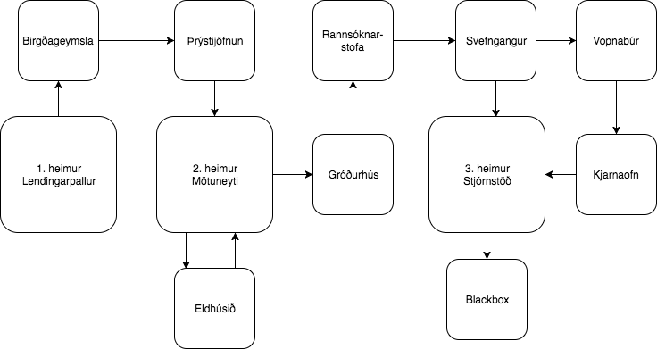

Mynd 1: Kerfismynd leiks

Á kerfismynd sjást 12 herbergi, 3 stór og 9 lítil. Stóru herbergin eru kölluð heimar 1, 2 og 3.

# Gameplay

Leikur hefst. Meginvalmynd opnast.

“Welcome to Lunartic, choose your character.”

Val á milli þriggja karaktera: Ismael, Natalie og Benjamin.

**Ismael** => “Congratulations, Ismael has 5 points for strength, 1 point for speed and 3 points for defence.”

**Natalie** => “Congratulations, Ismael has 3 points for strength, 5 points for speed and 1 point for defence.”

**Benjamin** => “Congratulations, Ismael has 1 point for strength, 3 points for speed and 5 points for defence.”

Gameplay hefst.

**Heimur 1 - Lendingarpallur**

“You wake up, lying on the landing pad of Lunar Station John. There is no-one around, where did everybody go?”

Mögulegar einingar: XXXXXXXXXX

“You found a door, do you want to enter? Y/N?”

**Heimur 1 - Birgðageymsla**

“You have entered into the storage facility, various packaged are lying around, some food packs have been opened…”

“You found a door, do you want to enter? Y/N?”

**Heimur 1 - Þrýstijöfnun**

“You have entered the airlock, press Y to remove your suit.”

“You found a door, do you want to enter? Y/N?”

**Heimur 2 - Mötuneyti**

“You have entered the cafeteria.”

“LOOK OUT! There’s a dead body on the floor!  
 Warning: there are two ways out of the cafeteria.”  
Mögulegar einingar: Skaðlaus Lunartic

“You found a door, do you want to enter? Y/N?”

**Heimur 2 - Eldhús**

“You have entered the kitchen, what a weird smell! Could it be poisonous gas?”

Mögulegar einingar: Gasgríma

“You found a door, do you want to enter? Y/N?”

**Heimur 2 - Gróðurhús**

“You have entered the greenhouse. What are these noises? They sound like screams…”

Mögulegar einingar: Skrúflykill

“You found a door, do you want to enter? Y/N?”

**Heimur 2 - Rannsóknarstofa**

“You have entered the laboratory...watch out! There’s a Lunartic running towards you!”

“Press X to draw weapon and fight!”

“You found a door, do you want to enter? Y/N?”

**Heimur 2 - Svefngangur**

“You have entered the sleeping hall, watch out for sleeping Lunartics.”

“You found a door, do you want to enter? Y/N?”

**Heimur 3 - Stjórnstöð**

“You have entered the control room, this is where you might find the blackbox.

Warning: there are two ways out of the control room.”

“You found a door, do you want to enter? Y/N?”

**Heimur 3 - Vopnabúr**

“You have entered the armory, why does it smell like kale in here?”

Möguleg eining: Kale smoothie

*Finnur smoothie* => “You found a kale smoothie, press Y to chug it down!”

“You found a door, do you want to enter? Y/N?”

**Heimur 3 - Kjarnaofn**

“You have entered the fusion chamber...look out! A radioactive Lunartic!”

*Ýtir á X* => “Good job, you have drawn you weapon, now fight!”

“You found a door, do you want to enter? Y/N?”

**Heimur 3 - Blackbox**

*Finnur blackbox* => “You have found the blackbox, let’s listen to the recording, make sure your sound is on.”

*Spilar upptöku*

“You have made a discovery! You win!”

**If-setningar**

Ef líf leikmanns = 0 kemur: “Out of life! You lose!”